

High Level Design & Low Level Design

**Index**

1. Introduction ------------------------------------------------ 3

1.1 Intended audience ------------------------------------------------ 3

1.2 Project purpose ------------------------------------------------ 3

1.3 Key project objective ------------------------------------------------ 3

1.4 Project scope ------------------------------------------------ 4

2. Design overview ------------------------------------------------ 4

2.1 Design objective ------------------------------------------------ 5

2.2 Design alternative ------------------------------------------------ 5

2.3 User interface paradigms ------------------------------------------------ 6

2.4 Validations ------------------------------------------------6

-

3. System architecture ------------------------------------------------ 7

3.1 Database architecture ------------------------------------------------ 7

4. Detailed system design -------------------------------------------------8

4.1 DFD 0 ------------------------------------------------8

4.2 DFD 1 ------------------------------------------------8

5. Tools Report -------------------------------------------------9

5.1 Gcov ------------------------------------------------9

5.2 Gprof ------------------------------------------------10

6. Testing ------------------------------------------------11

6.1 Unit Testing ------------------------------------------------11

6.2 Integration Testing —---------------------------------------------12

7. Requirements Traceability Matrix(RTM) ------------------------------------------------16

**1. Introduction**

* The aim of this document is to gather, analyze and give an in-depth insight into the complete Remote Line Editor for Text Files application by defining the problem statement in detail.
  + ·
* The detailed requirements of the Remote Line Editor for Text Files application is provided in this document.

**1.1 Intended Audience: -**

**1) Intended Audience for client: -**This application is intended to be used by, User.

**2) Intended Use for server:**

* Development Team
* Maintenance Team
* Admin

**1.2 Project Purpose: -**

* The best thing about this application is it helps users to produce an error free result within a few seconds.
* This application is compatible with almost every smart device having an internet connection.
* This application don’t require any installation process and provides the best options for editing tasks

**1.3 Key Project Objectives: -**

1. Client id is displayed whenever connection is established.
2. Signal Handling when server shutdowns abruptly.
3. Anonymous and Authenticated User.
4. Multiple clients connected to a single server.
5. Server shows the changes received from the edit command.
6. Signal Handling for client shutdown.

**1.4 Project scope : -**

This project aims for users to edit there text files easily from any device having internet connection.The user can easily access this application by just there User Id and Password from any device.This application don’t require any installation process and provides the best options for editing tasks and it is compatible with almost every smart device.

**2. Design Overview: -**

* **Remote Line Editor comprises of the following modules in maintain database:**

| Name of the Module | Change Directory command |
| --- | --- |
| Handled by |  |
| Description | The function is used to change the directory. |

| Name of the Module | list Directory command |
| --- | --- |
| Handled by |  |
| Description | The function is used to list the contents of the directory. |

| Name of the Module | print command |
| --- | --- |
| Handled by |  |
| Description | This function is used to print the contents inside the file. |

| Name of the Module | Edit command |
| --- | --- |
| Handled by |  |
| Description | This function is used to edit a particular line in the filename |

| Name of the Module | Select command |
| --- | --- |
| Handled by |  |
| Description | This function is used to select the filename. |

| Name of the Module | Help command |
| --- | --- |
| Handled by |  |
| Description | This command is used to list down all the commands inside the editor. |

| Name of the Module | help ls,print,edit |
| --- | --- |
| Handled by |  |
| Description | This command is used to tell the user about the syntax of the commands |

| Name of the Module | Bye command |
| --- | --- |
| Handled by |  |
| Description | This command is used to disconnect from the server. |

| Name of the Module | clear |
| --- | --- |
| Handled by |  |
| Description | This command is used to clear the screen. |

## Design Objectives:

1. Add different commands in the Line Editor
2. Start the connection
3. Accept the connection
4. Different commands should be able to print the desired output.
5. Remote Line Editor should be able to edit line
6. Signal Handling for server and client disruppts.
   1. **Design Alternative: -**

We have used a three structure to store data i.e. User, Server and Client and further typedef it and used in the program.

### 2.3 User Interface Paradigms: -

The Remote Line Editor should be able to allow the user to select files , print the contents and edit the particular line. Multiple clients should be able to connect one server.

### Validation: -

* The server and Client should be able to establish a connection successfully.
* There are two types of users Anonymous and Authenticated User. For anonymous users the username and password should be blank. But for authenticated users username and password credentials should match with the user.txt file.

**3. SYSTEM ARCHITECTURE: -**

**3.1. Database Architecture**

The database used inside our program is the user.txt file. The user.txt file contains username and password separated by space. We have used strtok with a delimiter as space to store username and password. Also for the present directory we can use username for the purpose.

The architecture used in this system is like that we store all the users inside a data folder in the home directory. And all the information of the authenticated and anonymous user stored in user.txt files.

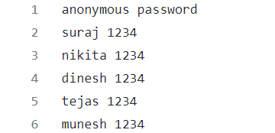

**4. DETAILED SYSTEM DESIGN:**

**4.1 DFD_0**

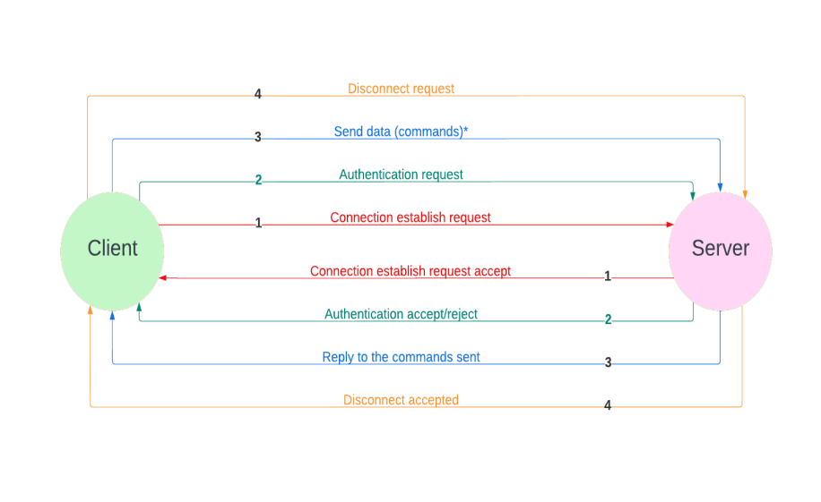

**4.2 DFD_1**

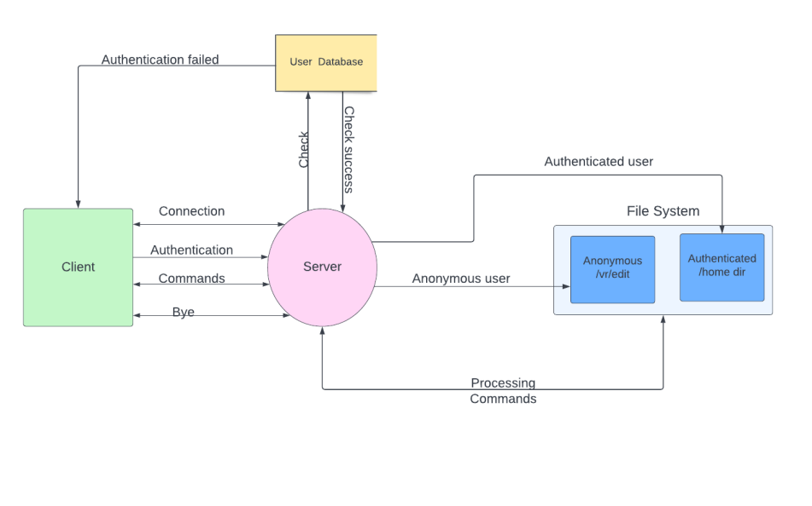

**5. TOOLS REPORT**

**5.1 Gcov tool**

**commands used**

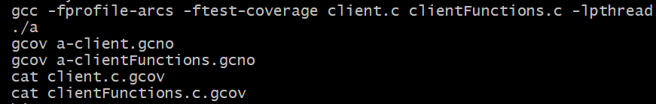

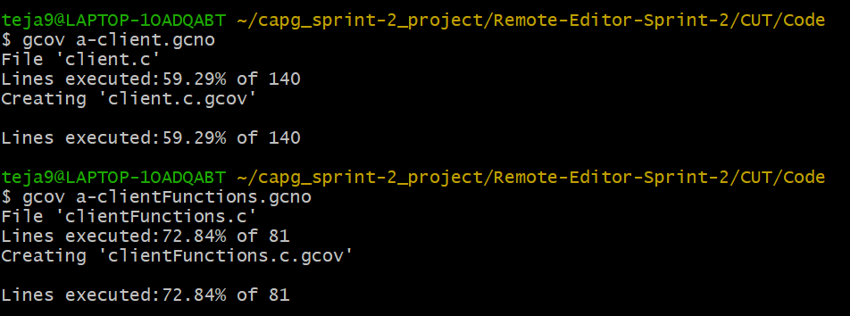

**clientFunctions.c.gcov :-**

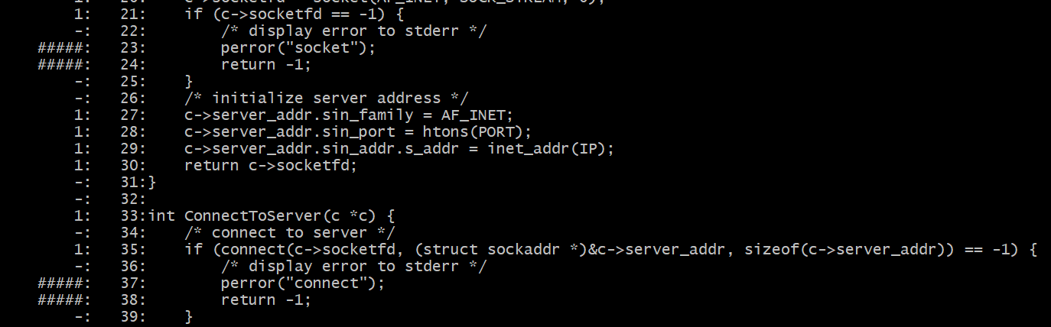

**5.2 Gprof Tool :-**



**Flat profile:-**

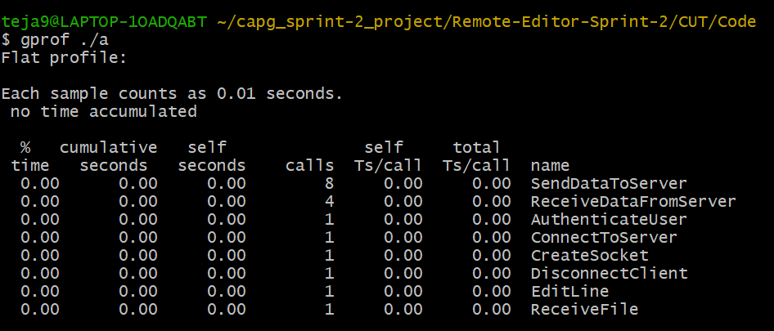

**Call Graph:-**

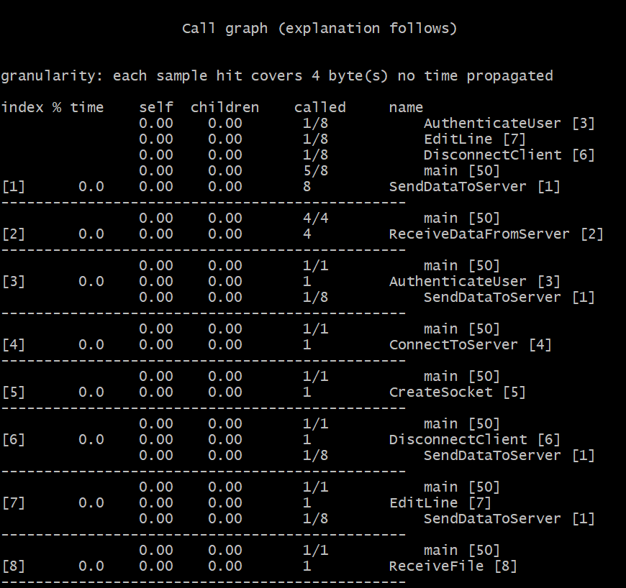

**6. Testing**

**6.1 Unit Testing**

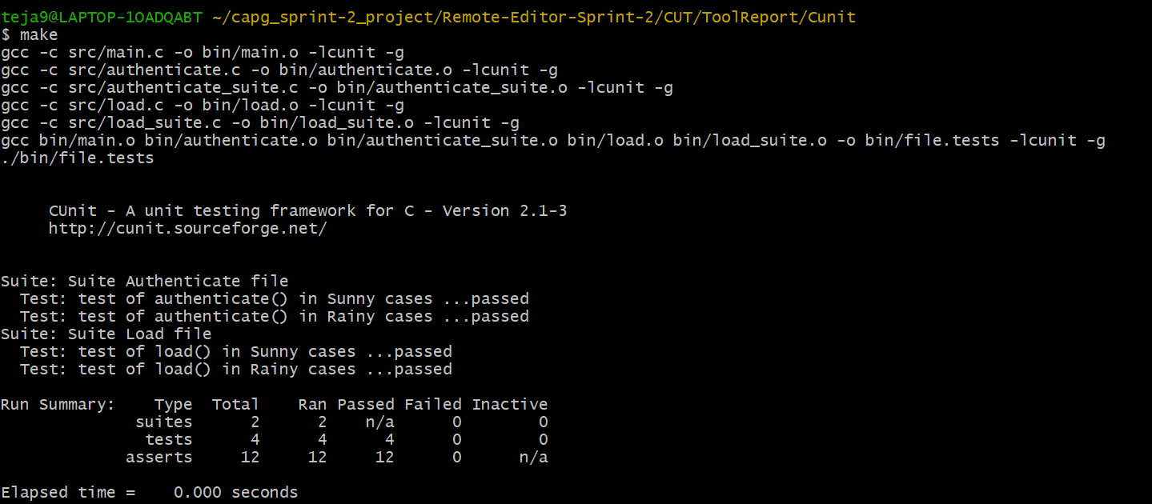

**6.2 Integration Testing**

**6.2.1 Authentication**

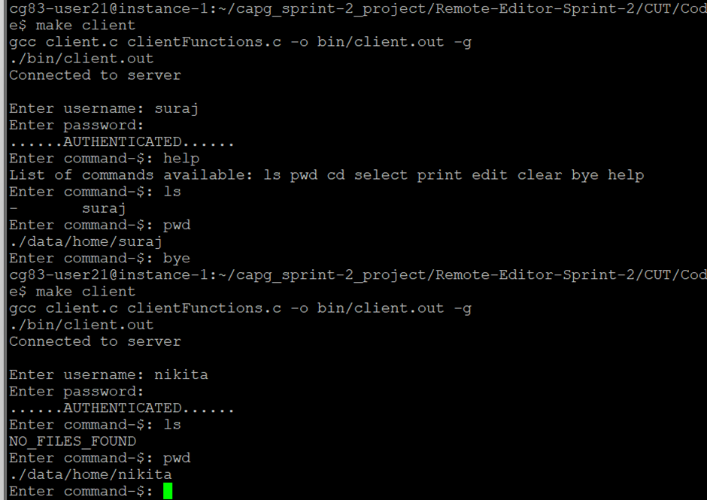

**6.2.2 Anonymous**

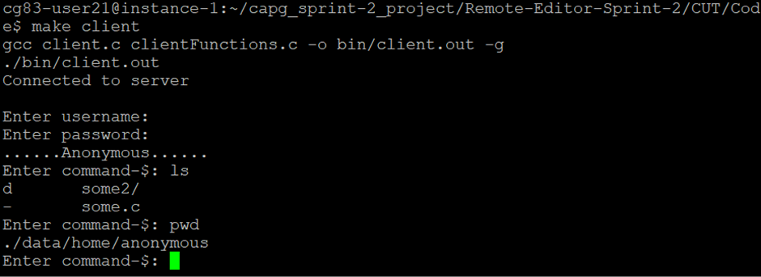

**6.2.3 cd and pwd**

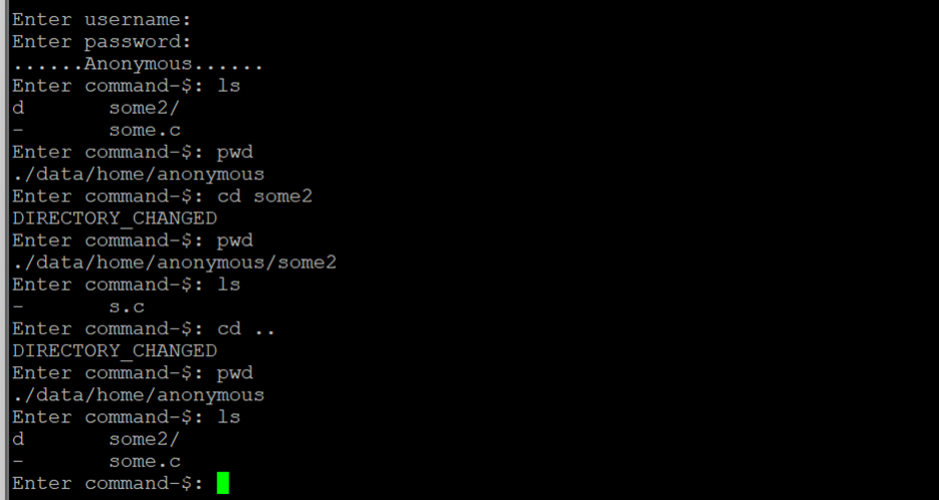

**6.2.4 Print**

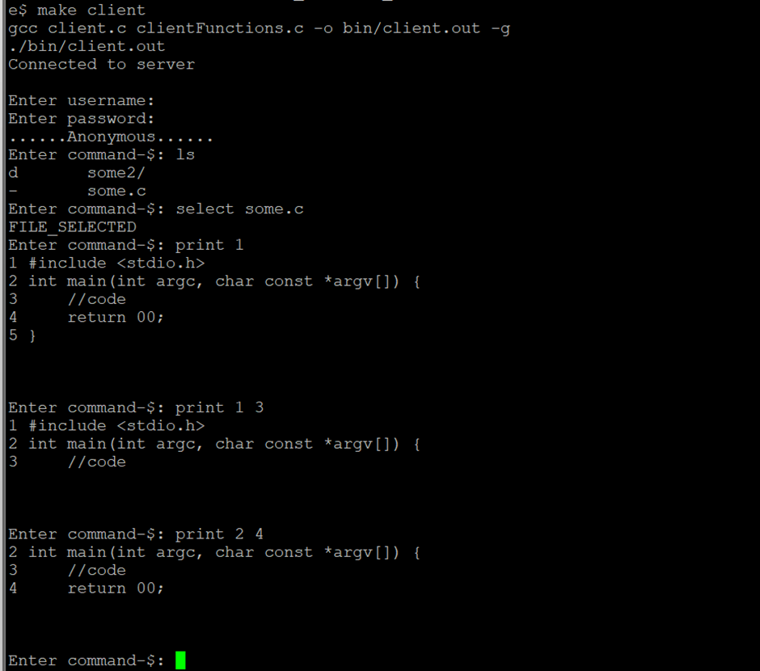

**6.2.5 Edit and invalid line number**

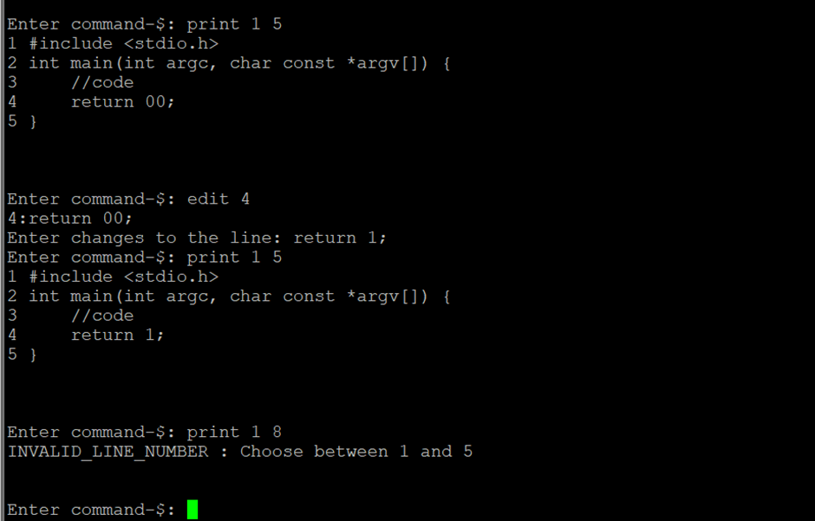

**6.2.6 Bye command**

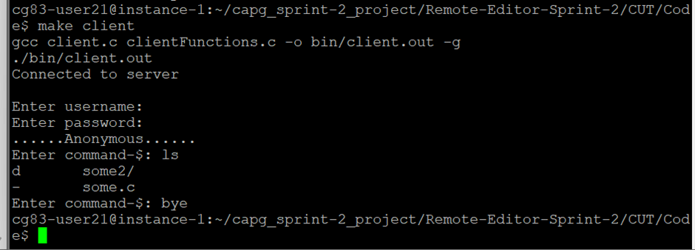

**6.2.7 help commands**

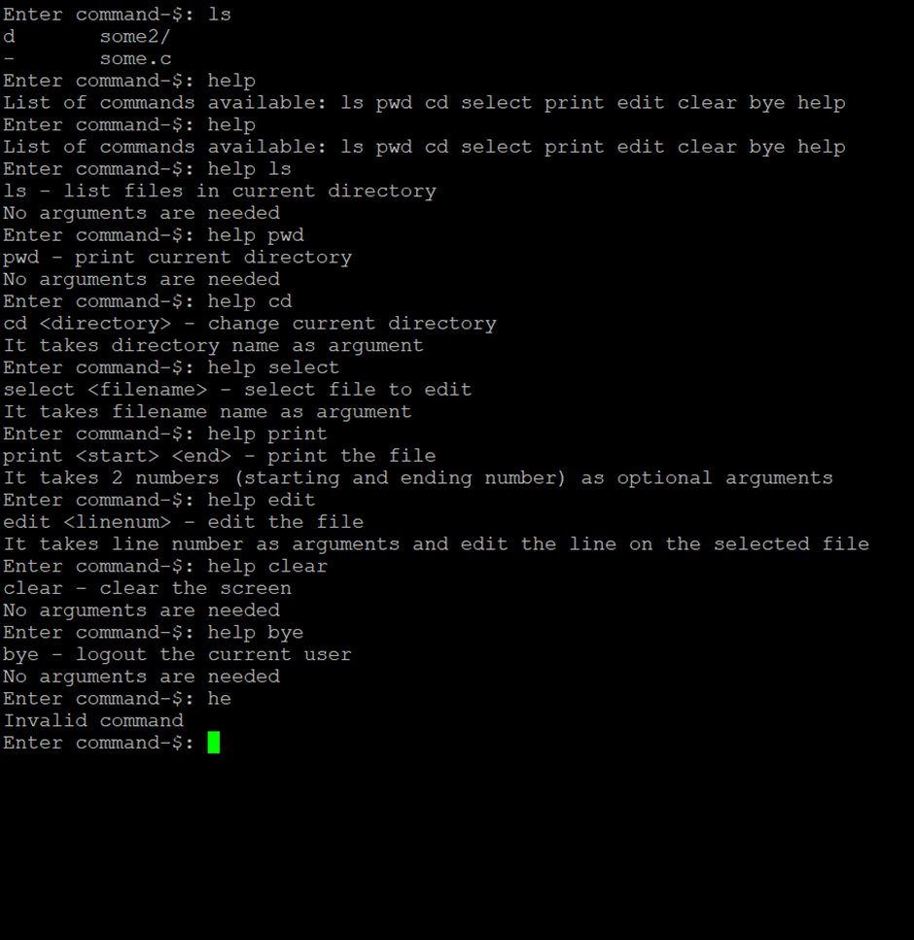

**7. Requirements Traceability Matrix(RTM)**

